DEFAULT

Name Here
Title Here
Hernandez Consulting & Construction
SDVOSB, 8(a)/SDB, HUBZone, DBE
Office: 504.305.8571
Cell: 405.444.4444
Fax: 504.617.6590
Email: NAME@hernandezconsulting.com
www.hernandezconsulting.com

DEFAULT with Address

Name Here
Title Here
Hernandez Consulting & Construction
SDVOSB, 8(a)/SDB, HUBZone, DBE
3221 Tulane Avenue
New Orleans, LA 70119
Office: 504.305.8571
Cell: 405.444.4444
Fax: 504.617.6590
Email: NAME@hernandezconsulting.com
www.hernandezconsulting.com

Here's how to create a signature in Outlook 2013 in five quick steps.
1. Click New Email at the top left corner of the Home tab.
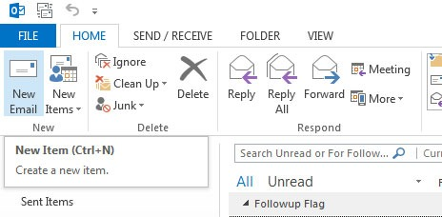
2. Click Signature from the top panel, next to Attach Item. A dropdown menu will appear, with options to add an existing signature to the email you're working on. Select Signatures from this menu to open a Signatures and Stationery window.
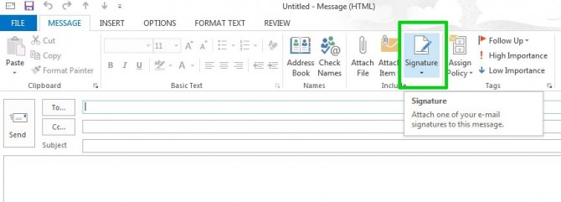

3. Click New in the Signatures and Stationery window to create a new signature template.
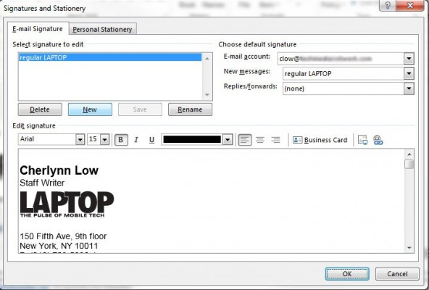

4. Compose your signature in the editing window. If you have your contact information already saved in Outlook, you can simply import all that information as a business card by clicking Business Card at the top right of the edit options.
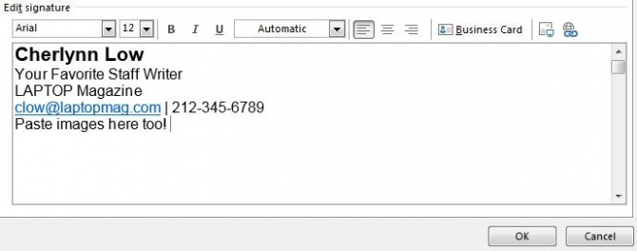
You can add images to your signature, like a logo or banner, by pasting them into the editor or clicking the button to the right of the Business Card button. URLs will be automatically hyperlinked, but if you want to add your own link, you can click the Insert Hyperlink button on the extreme right. Click OK, and your signature will be saved for future use.
5. Designate your new signature as your default in the Signatures and Stationery window if you want to make sure it is included with every new message and replies or forwards you send.
